
Architecture Governance & Management
EA Blueprint
SGLines
Table of Contents
1 Governance Management Structure and Role and Responsibilities 3
2 Processes for Architecture Compliance, Exceptions and Vitality 4
3 Governance Policies 5
4 Governance Practices 6
5 Skeletal Communication Plan 7
6 Change Management Process 8
7 Guidance to Outsourcing Initiative 9
8 Metrics to Measure Effectiveness 10

Document Information
Project Name: | EA Blueprint for SGLines
Prepared By: |  | Document Version No: | 0.1
Title: | Architecture Governance & Management | Document Version Date:
Reviewed By: |  | Review Date: | 11/05/2014
Distribution List
From | Date | Phone/Fax/Email

To | Action* | Due Date | Phone/Fax/Email
* Action Types: Approve, Review, Inform, File, Action Required, Attend Meeting, Other (please specify)
Document Version History
Version  Number | Version  Date | Revised By | Description | Filename

Governance Management Structure and Role and Responsibilities
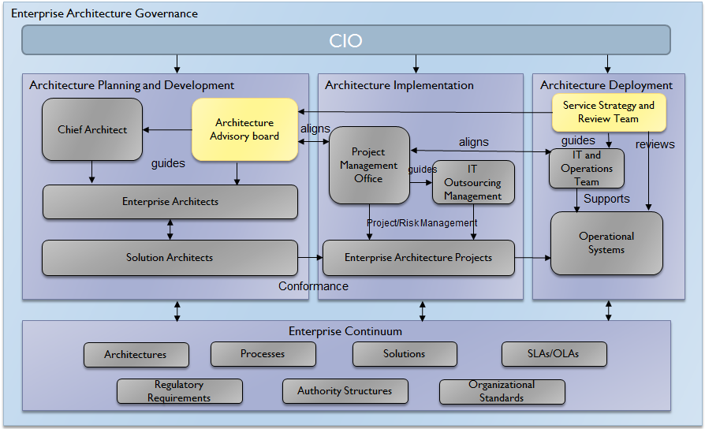

Processes for Architecture Compliance, Exceptions and Vitality

Governance Policies

Governance Practices

Skeletal Communication Plan

Change Management Process

Guidance to Outsourcing Initiative

Metrics to Measure Effectiveness

